LAPORAN RESMI

PRAKTIKUM PEMROGRAMAN BERORIENTASI OBJEK

ABSTRACT CLASS DAN INTERFACE



Fadilah Fahrul Hardiansyah S.ST., M. Kom

Ratri Maria Manik

3121600039

D4 TEKNIK INFORMATIKA – B

PROGRAM STUDI TEKNIK INFORMATIKA

POLITEKNIK ELEKTRONIKA NEGERI SURABAYA

TA 2022/2023

1. **PERCOBAAN**
2. Abstract Class
3. Class Binatang

|  |
| --- |
| public abstract class Binatang {  public void bernafas(){  System.out.println("semua binatang bernafas");  }  public void makan(){  System.out.println("semua binatang makan");  }  public void berkembangBiak(){  }  }  class Burung extends Binatang{  public void makan(){  super.makan();  System.out.println("burung makan biji-bijian");  }  public void berkembangBiak(){  System.out.println("burung berkembang biak dengan cara bertelur");  }  }  class Mamalia extends Binatang{  public void berkembangBiak(){  System.out.println("mamalia berkembang biak dengan cara melahirkan");  }  } |

1. Class TestAnimal

|  |
| --- |
| public class TestAnimal {  public static void main(String args[]){  Binatang loveBird = new Burung();  Binatang cat = new Mamalia();  Mamalia dolphin = new Mamalia();  loveBird.bernafas();  loveBird.makan();  loveBird.berkembangBiak();  cat.bernafas();  cat.makan();  cat.berkembangBiak();  dolphin.berkembangBiak();  }  } |

1. Hasil Output

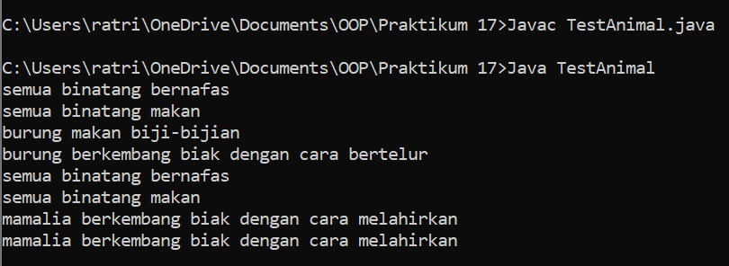

1. Interface Class
2. Class Phone

|  |
| --- |
| public class Phone{  public String phoneNumber;  public void call(){  }  public void receiveCall(){  }  } |

1. Interface Camera

|  |
| --- |
| public interface Camera{  public void captureImage();  } |

1. Interface CardReader

|  |
| --- |
| public interface CardReader{  public void readCard();  } |

1. Class SmartPhone

|  |
| --- |
| public class SmartPhone extends Phone implements Camera, CardReader{  String phoneNumber;  Lens lens;  public void call(){  }  public void receiveCall(){  }  public void captureImage(){  }  public void readCard(){  }  } |

1. **LATIHAN**
2. Pengimplementasian abstract class terhadap diagram UML

|  |
| --- |
| public abstract class Weapon{  public abstract void attack();  public void info(){  System.out.println("Senjata");  }  }  class Knife extends Weapon{  public String knifeEdge;  public void attack(){  System.out.println("Menyayat dan menusuk musuh");  }  }  class Gun extends Weapon{  public int bullets;  public Gun(int bullets){  this.bullets = bullets;  }  public void attack(){  super.info();  System.out.println("Menembakkan peluru");  this.bullets -= 1;  System.out.println("Sisa peluru : " + this.bullets);  }  } |

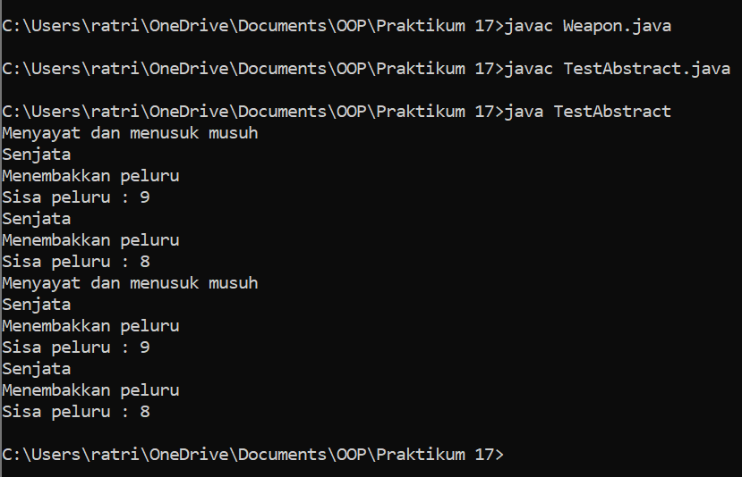

1. Perbaiki kesalahan pada program

|  |
| --- |
| public interface Scanner{  public void scaneImage(){  System.out.println("Scanning image...");  }  }  public interface Copier{  public void copyImage();  }  public class Printer implements Copier, Scanner{  public void scaneImage(){  System.out.println("Scanning image...");  }  public void copyImage(){  System.out.println("Copy image...");  }  public void printImage(){  System.out.println("Print image...");  }  } |

Analisa :

Pada program di atas terdapat kesalahan pada interface (interface Scannner), yang dimana method pada interface tersebut terdapat body, sedangkan pada interface inisialisasi method harus kosong.

1. **TUGAS**

|  |
| --- |
| <<interface>>  ***UsbFlash*** |
|  |
| + storageMedia(): void |

|  |
| --- |
| <<interface>>  ***Gun*** |
|  |
| + laserPointer(): void |

|  |
| --- |
| BallPoint |
|  |
| + draw(): void  + laserPointer(): void  + storageMedia(): void |

1. Interface UsbFlash

|  |
| --- |
| public interface UsbFlash{  public void storageMedia();  } |

1. Interface Gun

|  |
| --- |
| public interface Gun{  public void laserPointer();  } |

1. Class BallPoint

|  |
| --- |
| public class BallPoint implements UsbFlash, Gun{  public void draw(){  }  public void laserPointer(){  }  public void storageMedia(){  }  } |